**Extremely randomized trees**

In Random forest what we do is col. Sampling, row sampling and aggregation.

And if some real valued feature comes then what we do in RF and DT is sort that feature and then try out all the posibile values of fi to determine tou

But In extremely randomized tree for real valued feature we try out a random sample of possible values to determine tou not all possible values this is the only difference b/w RF and extremely randomized tree(ERT)

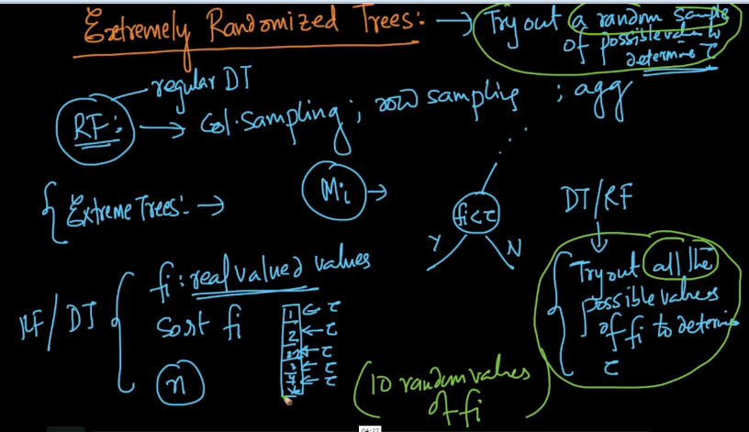

Therefore in ERT along with steps of RF i.e column sampling + row sampling + aggregation we also do randomization when selecting tou

